How to use metadatactvity to create list of the files in folder

1. Create datasets
2. Drag and drop meta data activity
3. Go to the settings select dataset and add child items in field list

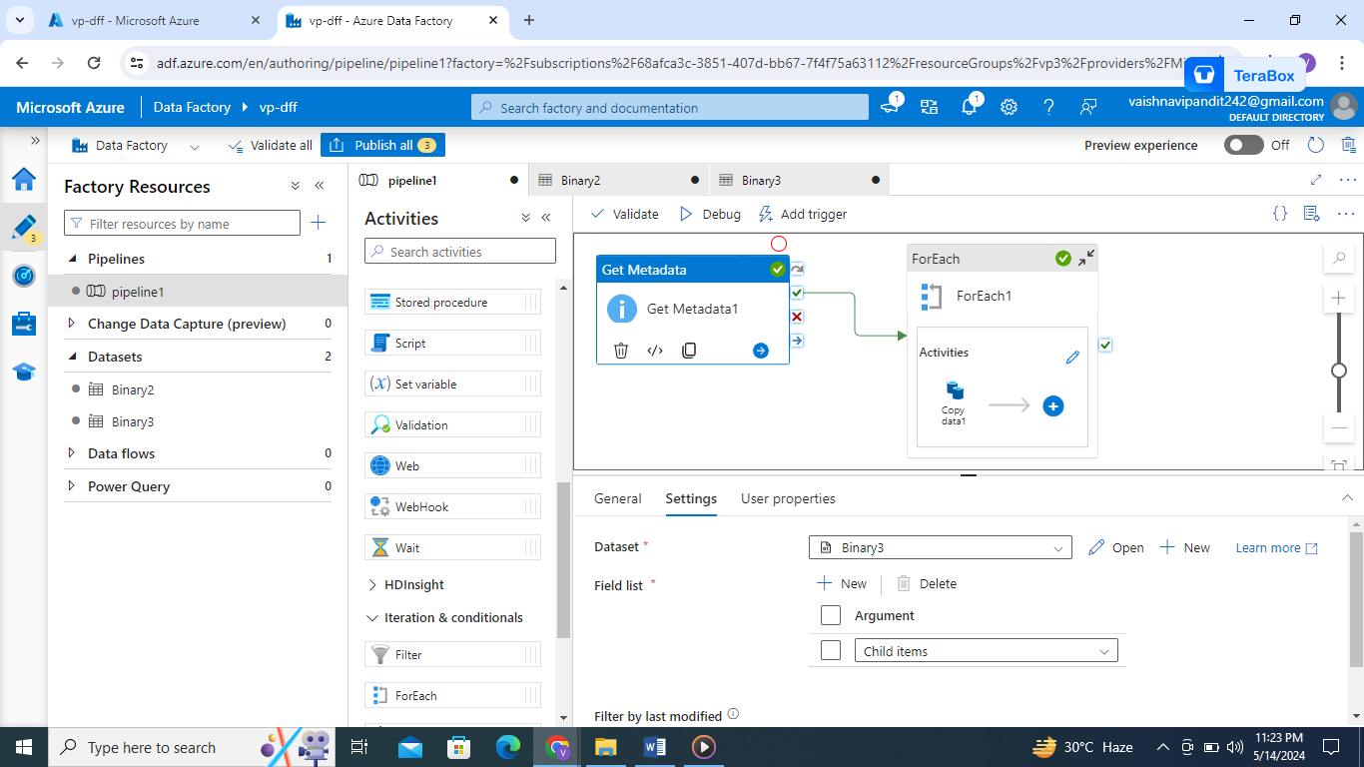

1. Then create for each activity

Go to settings in items go to add dynamic content and select the get meta data activity child items

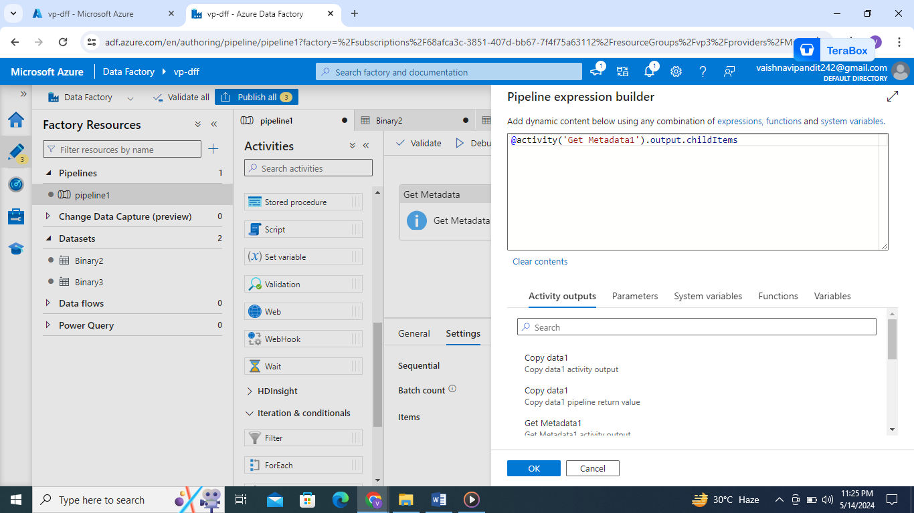

1. Now go to the activity
2. And select copy data add source and sink that it now debug it